Investigating Complaints
Pontypool Medical Centre will investigate all complaints effectively and in conjunction with up-to-date legislation and guidance
Confidentiality
Pontypool Medical Centre will ensure that all complaints are investigated with the utmost confidentiality and that any documents are held separately from the patient’s healthcare record.

Third party complaints
Pontypool Medical Centre allows a third party to make a complaint on behalf of a patient. The patient must provide consent for them to do so. This form is available from reception.

Final response
Pontypool Medical Centre will issue a final formal response to all complainants which will provide full details and the outcome of the complaint.

Advocacy support
- Contact LLAIS Tel No: 01633 838516 Email:gwentadvocacy@llaiscymru.org Website: Gwent | LLais (llaiswales.org)
- Contact Age UK Tel No: 0300 303 4498 Email: advice@agecymru.org.uk. Website: https://www.ageuk.org.uk/cymru/
- Contact POhWER support centre Tel No: 0300 456 2370

Further action
If you are dissatisfied with the outcome of your complaint from the practice or Aneurin Bevan then you can escalate your complaint to:
Public Service Ombudsman for Wales
1 Ffordd yr Hen Gae
Pencoed
CF35 5LJ
Tel No: 0300 790 0203
www.ombudsman-wales.org.uk

The
Complaints
Process

Pontypool Medical Centre

PontypoolPontypool
Pontypool

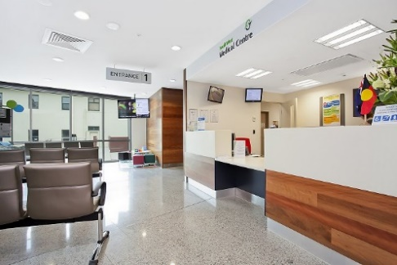
NE
Talk to us

Every patient has the right to make a complaint about the treatment or care they have received at Pontypool Medical Centre We understand that we may not always get everything right and, by telling us about the problem you have encountered, we will be able to improve our services and patient experience

Who to talk to
Most complaints can be resolved at a local level. Please speak to a member of staff if you have a complaint; our staff are trained to handle complaints. Alternatively, ask to speak to Maria Potter, Practice Manager or Louise Rosser, Operations Manager

We are supported by our central team and if you do not wish to speak to the practice you can email Sally White, Patient Relations Manager at complaints@eharleystreet.co.uk

You can contact the Aneurin Bevan ‘Putting Things Right Team’ for clinical complaints at -:

Tel No: 01495 745656
Email Address:
Puttingthingsright.abb@wales.nhs.uk
Website Address: NHS Wales complaints and concerns: Putting Things Right | GOV.WALES

Time frames for complaints
The time constraint on bringing a complaint is 12 months from the occurrence giving rise to the complaint, or 12 months from the time you become aware of the matter about which you wish to complain.
We will aim to acknowledge receipt all complaints within three business days.
We will aim to investigate and provide you with the findings as soon as we can and will provide updates if we are unable to meet our timelines regarding the investigation of your complaint.

